To use your personal Yahoo Email address within Maestro to send to your patients, a few changes need to be made within your Yahoo account for this to be possible.

Things you will need:
- Access to your Yahoo account.
Per Yahoo security measures, these steps must be followed within your Yahoo account or Yahoo will likely not work within Maestro. These changes are not at our control and are subject to change at Yahoos discretion.
There are three parts to this process, two of which will happen in Yahoo, one in Maestro.
Part One:
- Go to https://login.yahoo.com/myaccount/security/. You will have to be logged in to access this page, but if you are not already, it will prompt you to do so. Please be sure to log into the account you wish to use for emailing.
- On the left menu, select “Account Security”
- Scroll down the middle of the page until you the “Other ways to sign in” App Password section
- Select “Generate App Password”
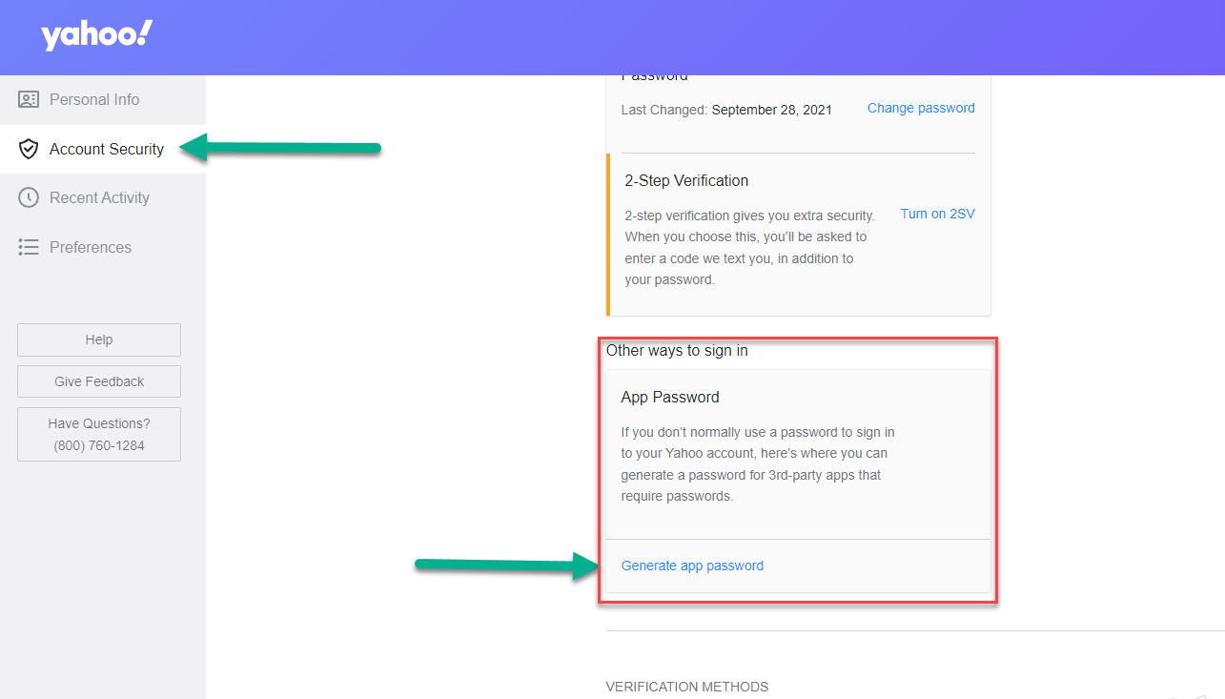
- In the App Name field, enter “Maestro” and then Select “Generate Password”
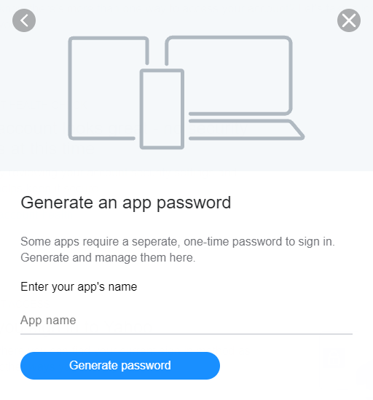
- Stop here. This step is very important as you will not see this password again. Although the screen tells you not to write it down, we recommend you write it down now. Remember that passwords are case sensitive, so write it down exactly how it is shown. Spaces are not needed. (Note that the password in the picture below is not valid, do not use)
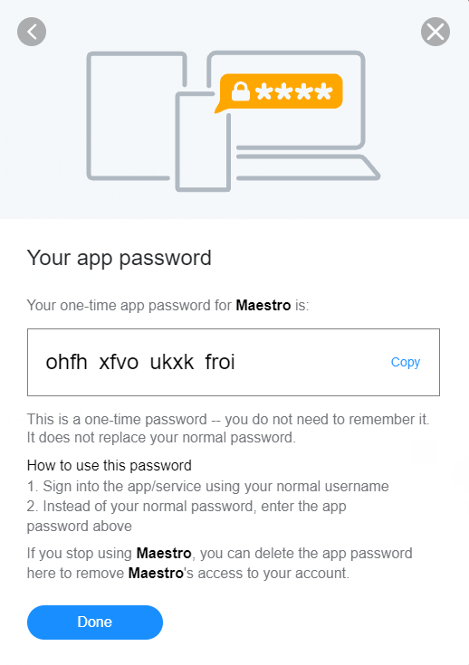
- Once you have written down the password, select Done

Part Two:
To use Yahoo in Maestro, the email account you use in Maestro must be a Yahoo address. (Before proceeding below, check this by going to Setup and Organization).
- In Maestro, select “Setup” on the top menu bar.
- Select “Settings” on the bottom menu bar.
- Select “Settings 2” just under the top menu bar.
- Toggle the “Allow Edits” button from Off to On
- Make sure that the radio button for “Use Your Yahoo Account to Send eMail” is filled, then enter the 16-digit password you received from Yahoo in Part One.
- Toggle the “Allow Edits” button from On to Off
- Exit Maestro and then go back in.
